**Week 2**

**PL/SQL**

**Exercise 1: Control Structures**

**Scenario 1:**

The bank wants to apply a discount to loan interest rates for customers above 60 years old.

* + Question: Write a PL/SQL block that loops through all customers, checks their age, and if they are above 60, apply a 1% discount to their current loan interest rates.

**Query and output:**

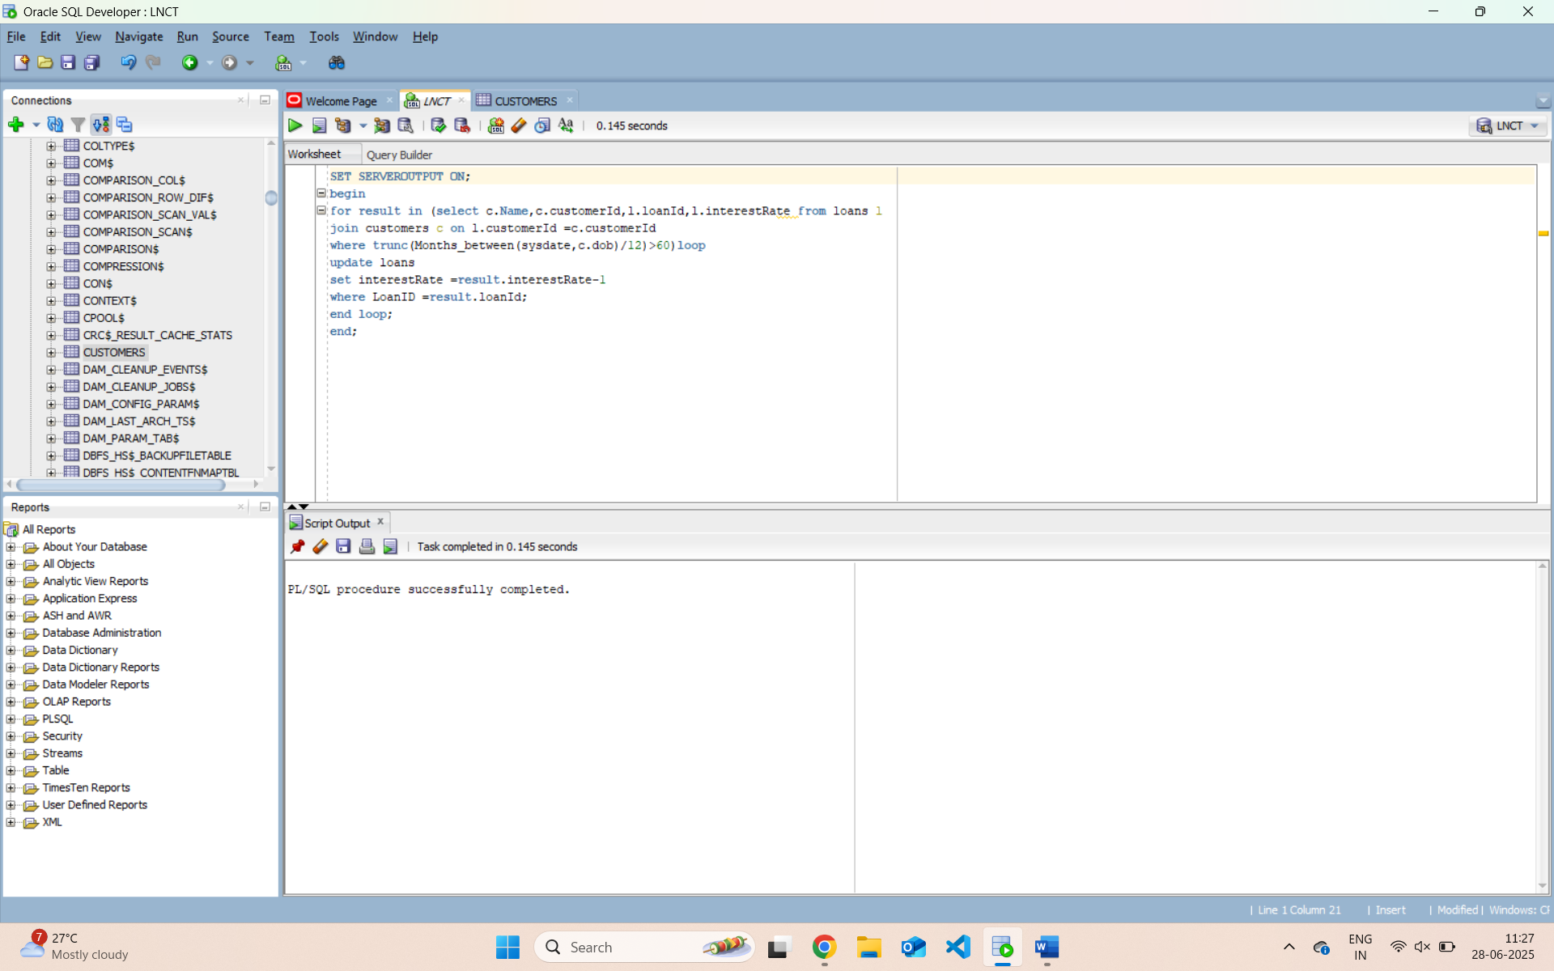

**Scenario 2:**

A customer can be promoted to VIP status based on their balance.

* + Question: Write a PL/SQL block that iterates through all customers and sets a flag IsVIP to TRUE for those with a balance over $10,000

**Query and output**

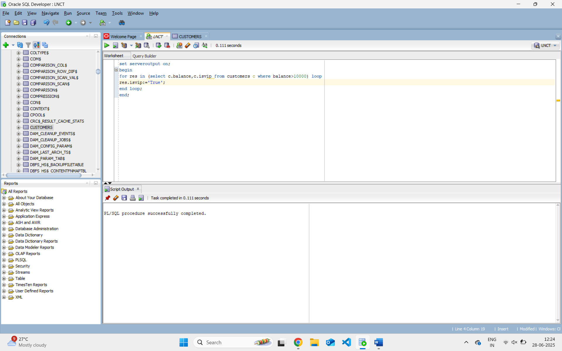

**Scenario 3:**

The bank wants to send reminders to customers whose loans are due within the next 30 days.

* + **Question:** Write a PL/SQL block that fetches all loans due in the next 30 days and prints a reminder message for each customer.

**Query and output:-**

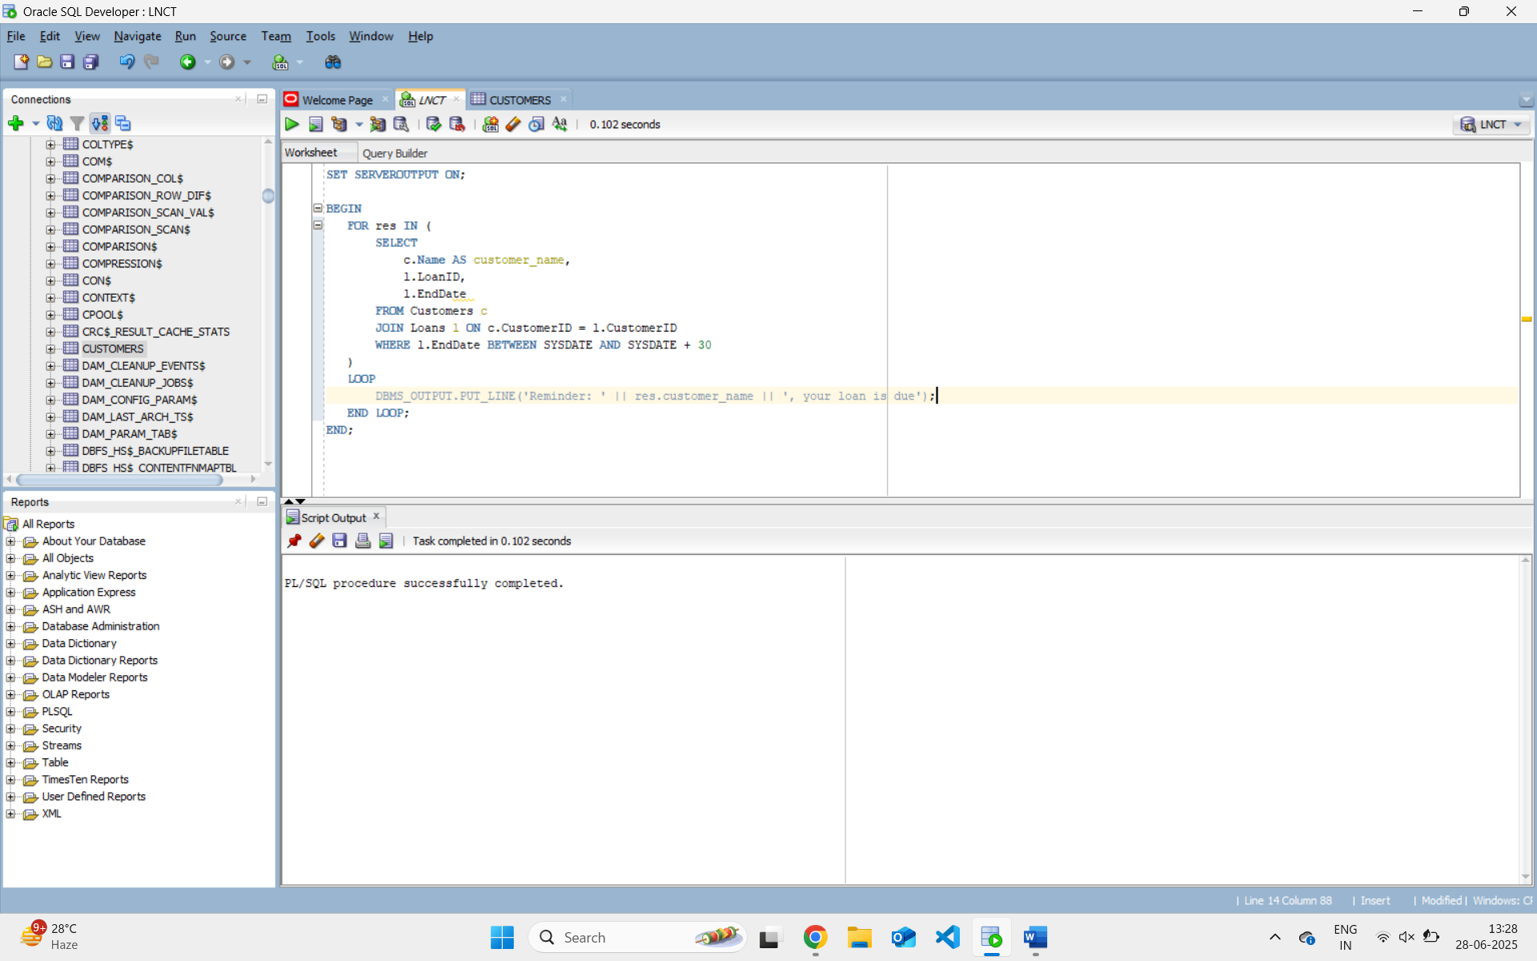

**Exercise 3: Stored Procedures**

**Scenario 1:**

The bank needs to process monthly interest for all savings accounts.

* + **Question:** Write a stored procedure **ProcessMonthlyInterest** that calculates and updates the balance of all savings accounts by applying an interest rate of 1% to the current balance.

**Query and output :-**

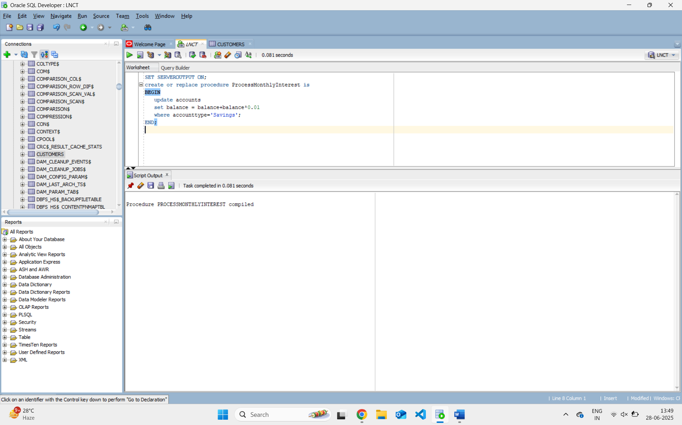

**Procedure Call :-**

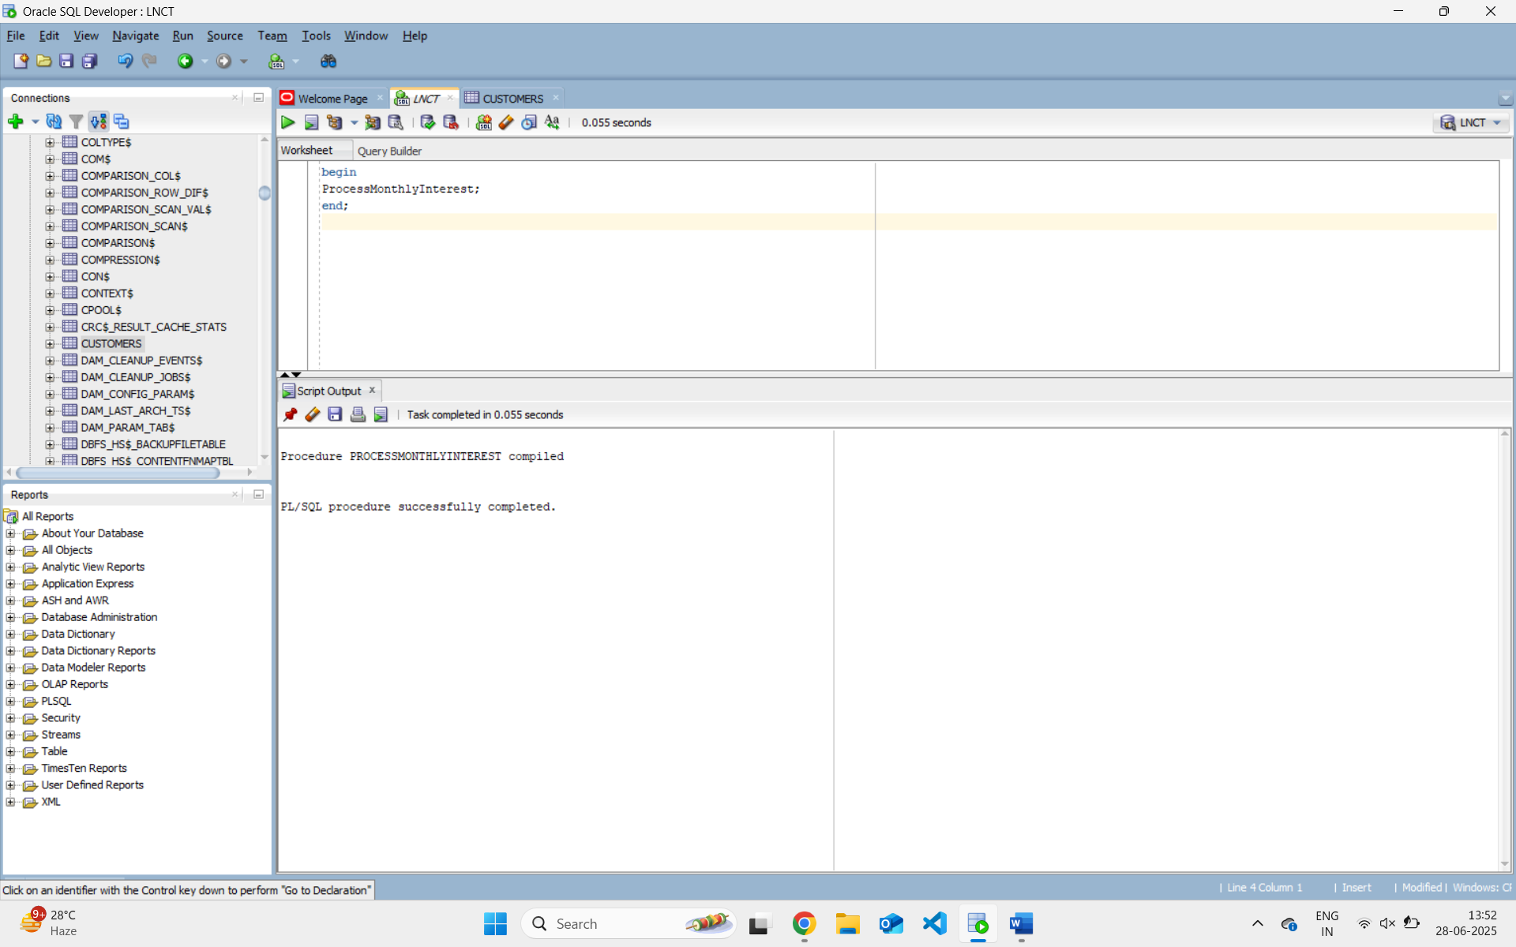

**Scenario 2:**

The bank wants to implement a bonus scheme for employees based on their performance.

* + **Question:** Write a stored procedure **UpdateEmployeeBonus** that updates the salary of employees in a given department by adding a bonus percentage passed as a parameter.

**Query and output:-**

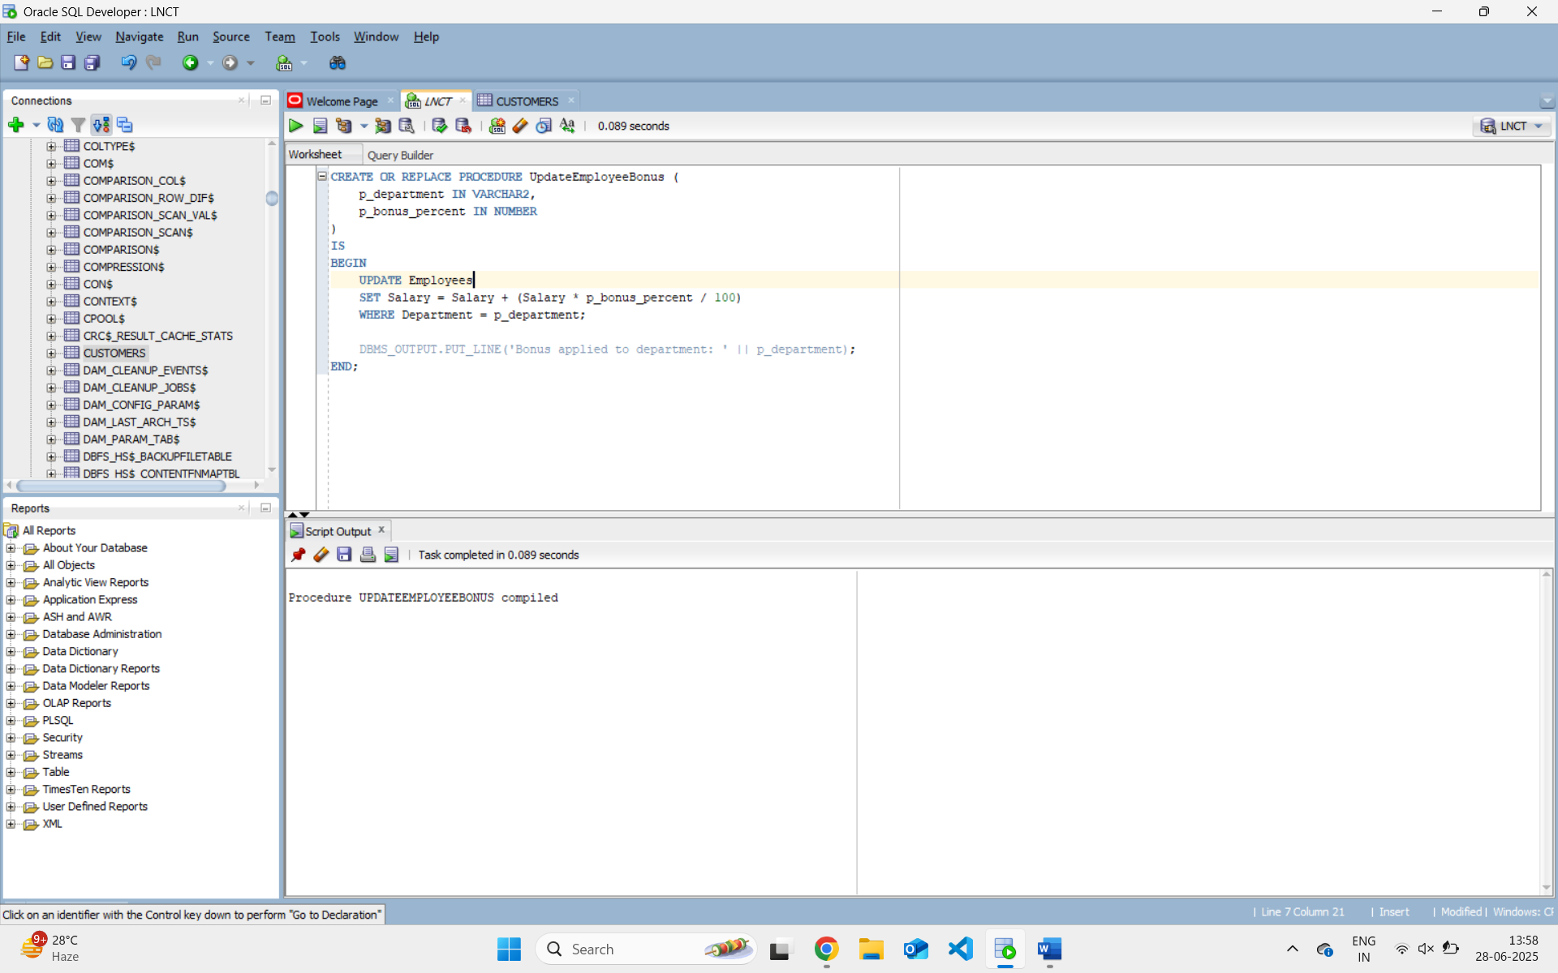

**Procedure Call :-**

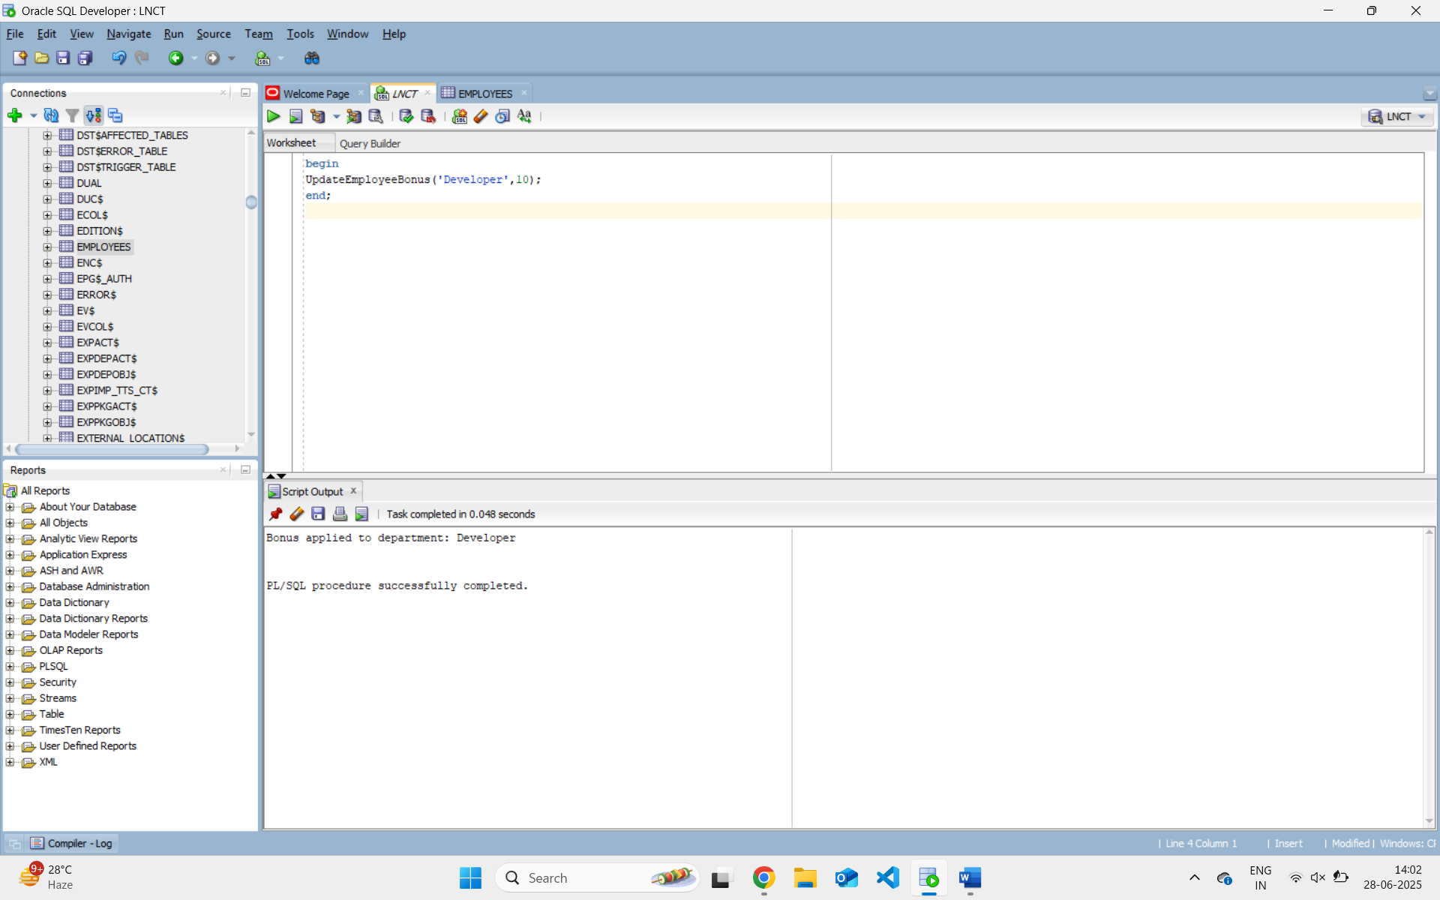

**Scenario 3:**

Customers should be able to transfer funds between their accounts.

* + **Question:** Write a stored procedure **TransferFunds** that transfers a specified amount from one account to another, checking that the source account has sufficient balance before making the transfer.

**Query and output:-**

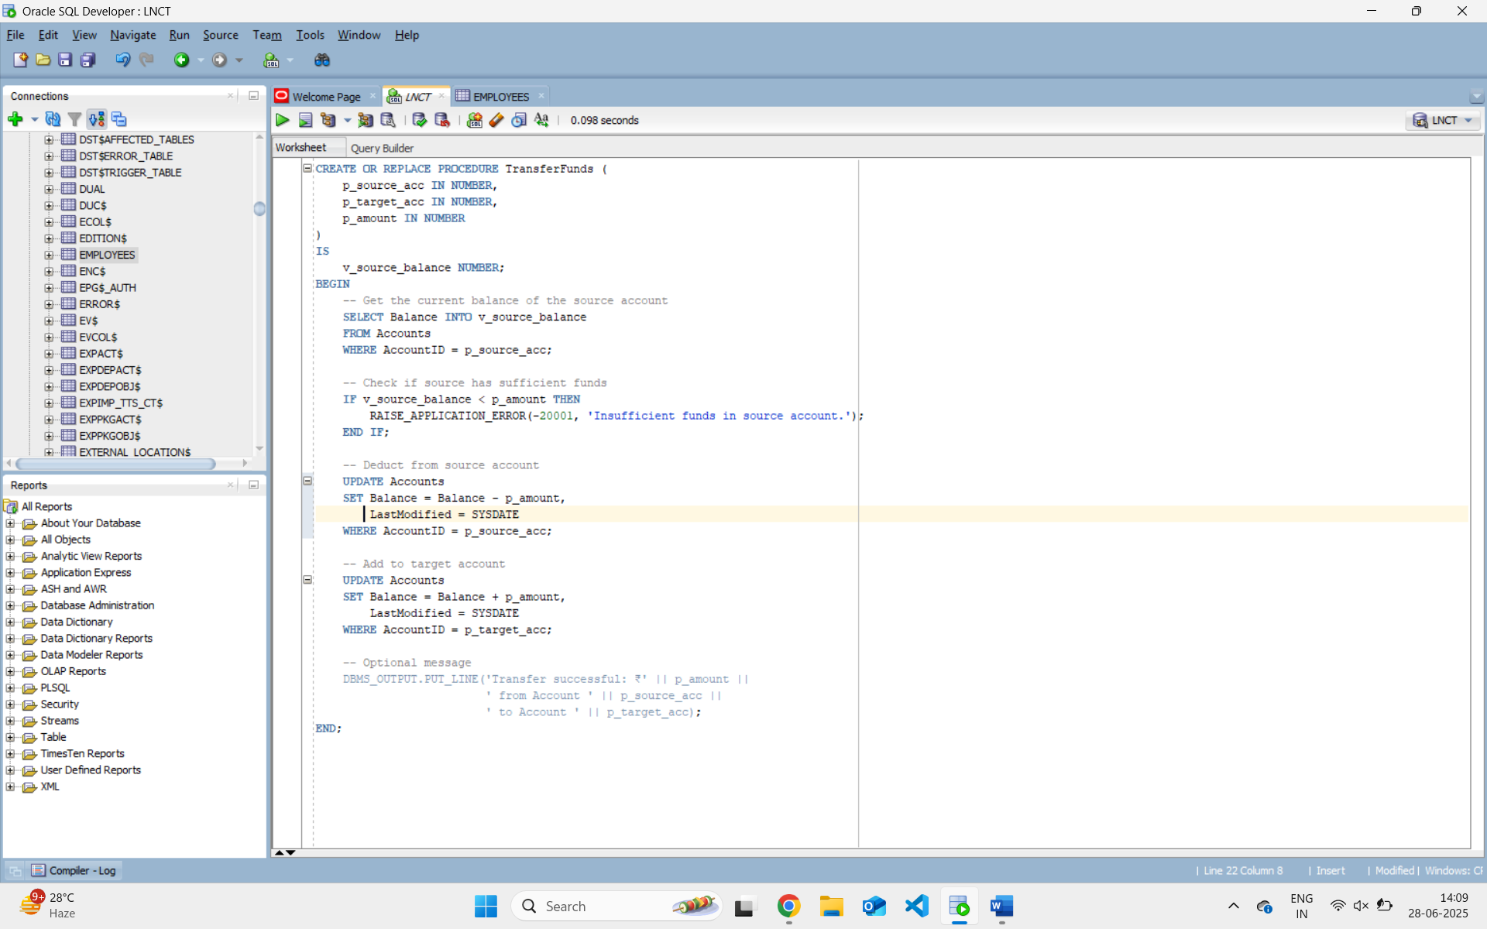 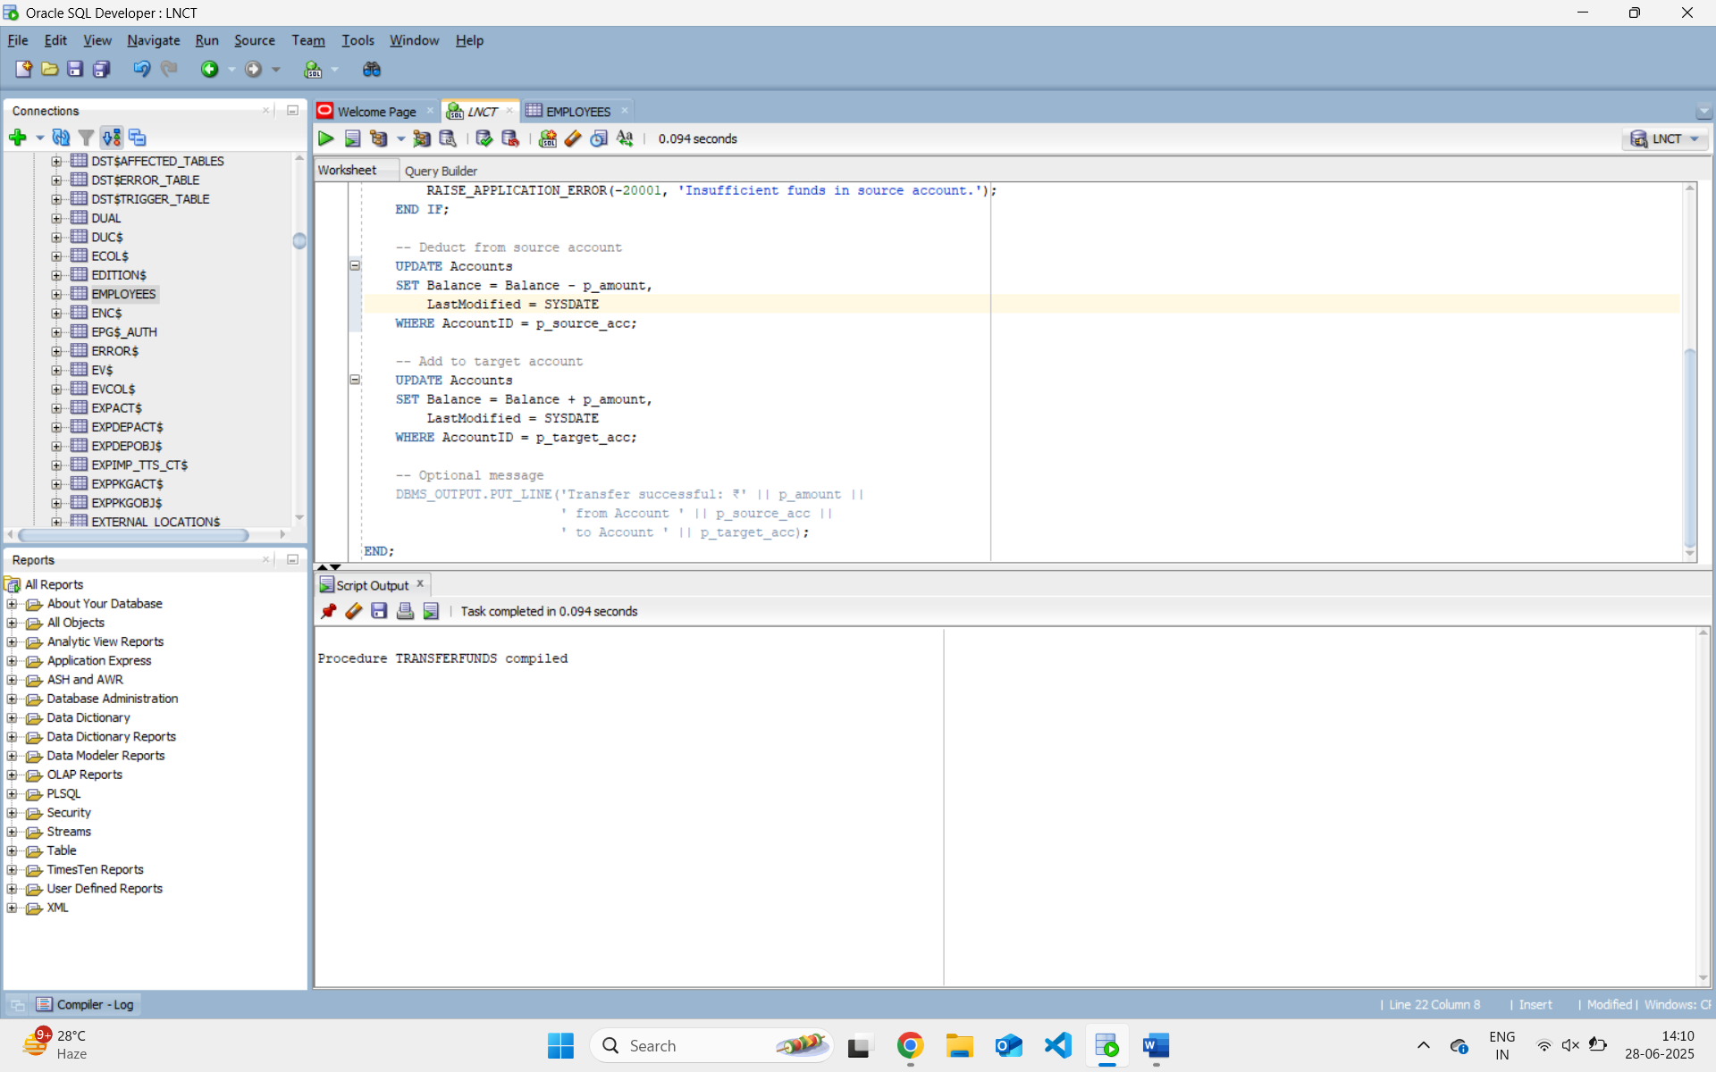

Procedure Call :-

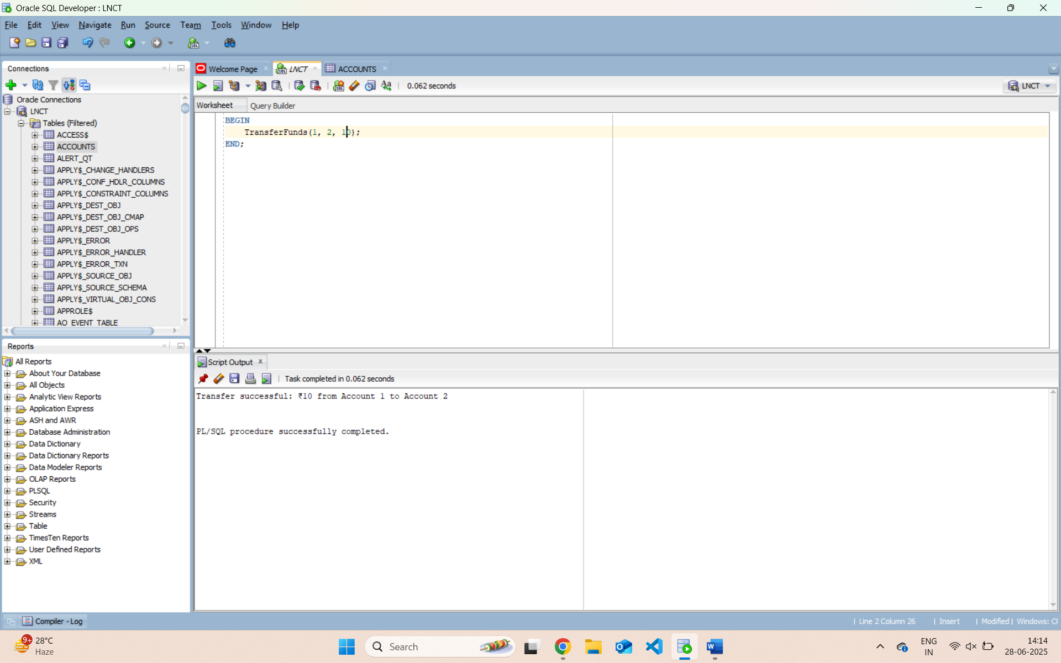

**JUnit Testing Exercises**

**Exercise 1: Setting Up Junit**

**Scenario:**

You need to set up JUnit in your Java project to start writing unit tests.

**Step 1: Create a New Java Project**

**In IntelliJ IDEA.**

1. Open IntelliJ IDEA.
2. Click on **New Project**.
3. Choose **Maven** on the left pane.
4. Click **Next**.
5. Enter:
   * **GroupId**: e.g., com.example
   * **ArtifactId**: e.g., JUnitDemo
6. Click **Next**, then **Finish**.

**Step 2: Add JUnit Dependency**

* + 1. Open the pom.xml file.

2. Add this inside the <dependencies> tag:

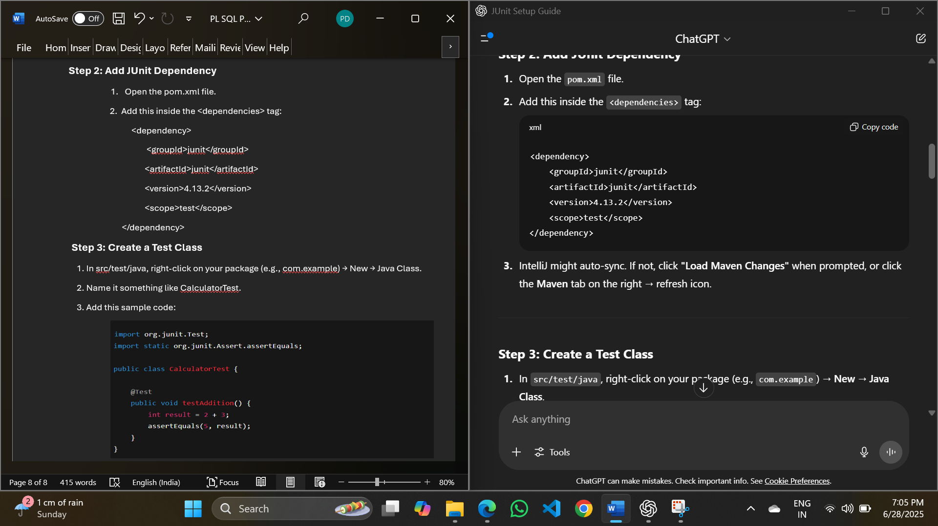

**Step 3: Create a Test Class**

1. In src/test/java, right-click on your package (e.g., com.example) → New → Java Class.

2. Name it something like CalculatorTest.

3. Add this sample code:

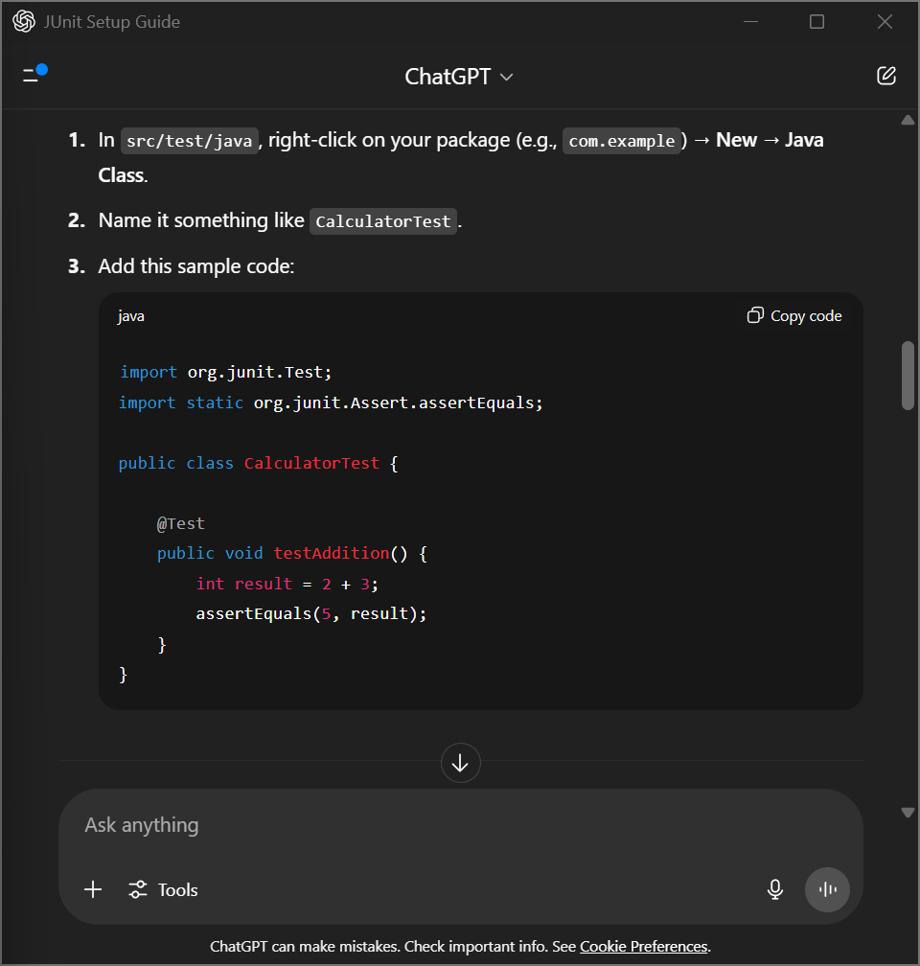

**OUTPUT:**

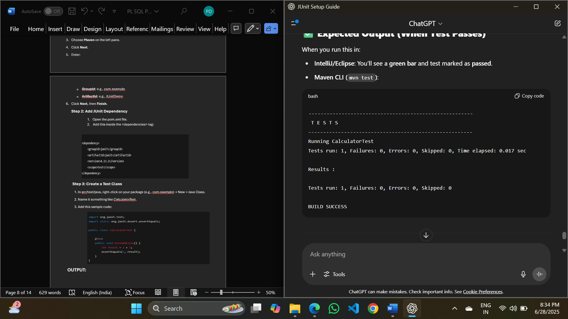

**Exercise 2: Assertions in Junit**

**Scenario:**

You need to write basic JUnit tests for a simple Java class.

**JUnit Test Class Using Assertions:**

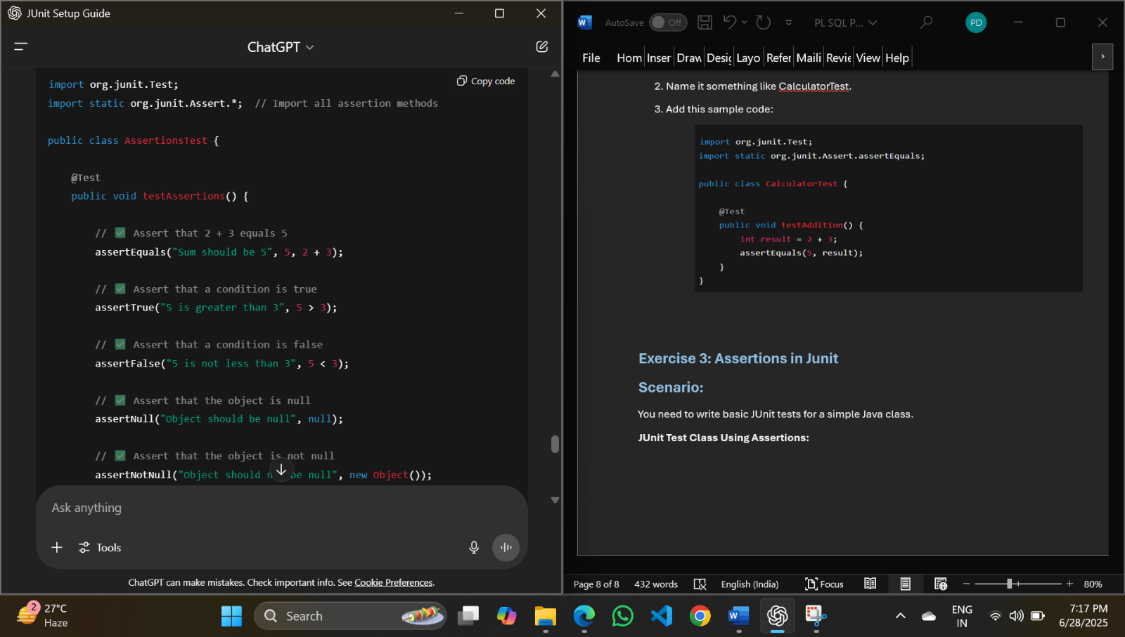

**0UTPUT:**

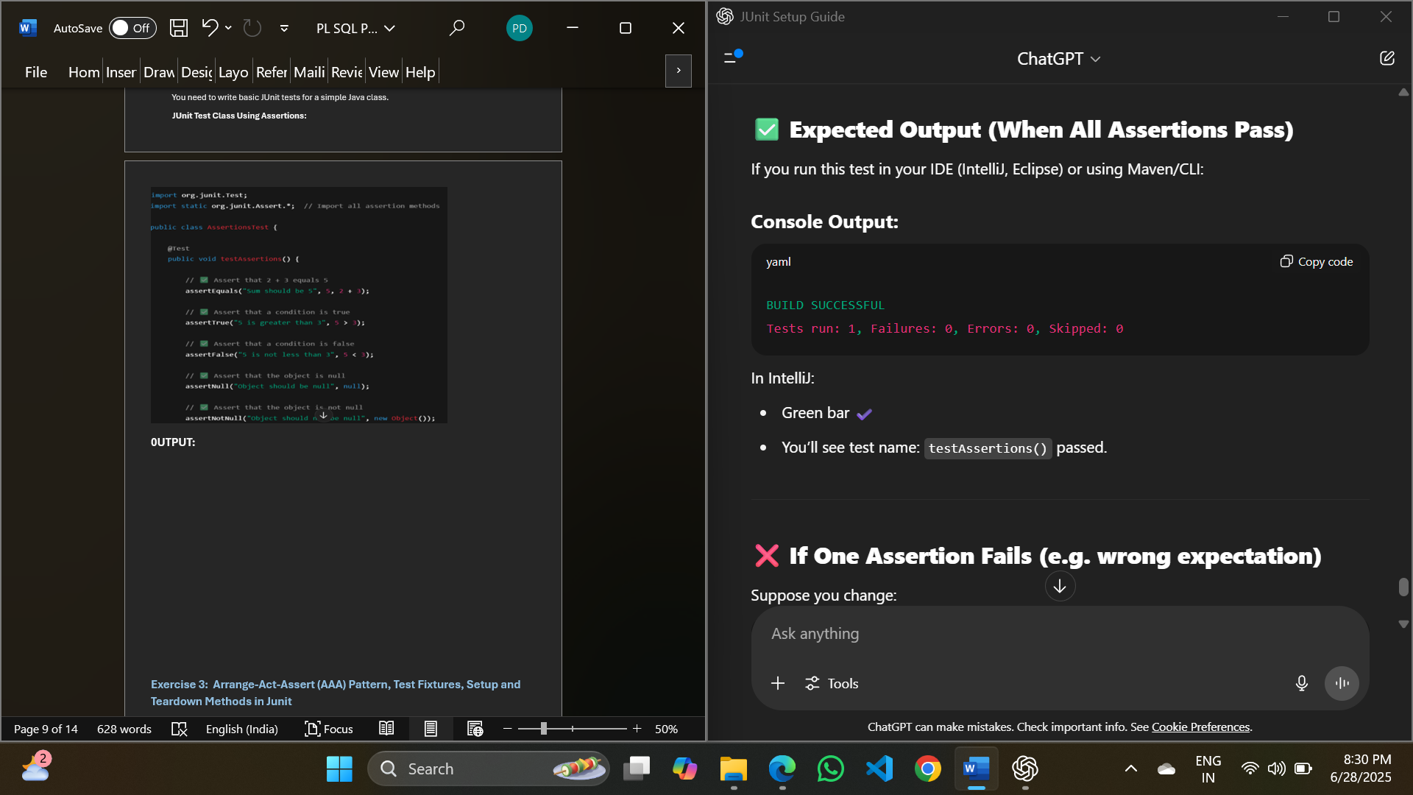

**Exercise 3: Arrange-Act-Assert (AAA) Pattern, Test Fixtures, Setup and Teardown Methods in Junit**

**Scenario:**

You need to organize your tests using the Arrange-Act-Assert (AAA) pattern and use setup and teardown methods.

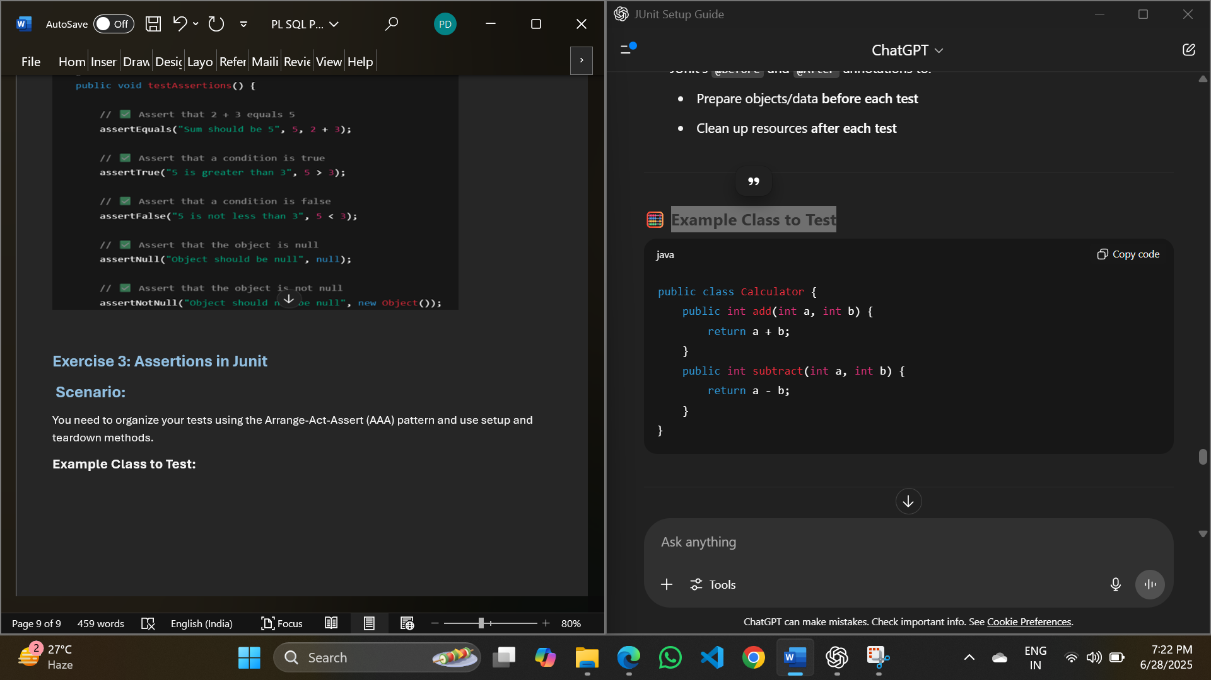**Example Class to Test:**

**JUnit Test Class Using AAA, Setup and Teardown:**

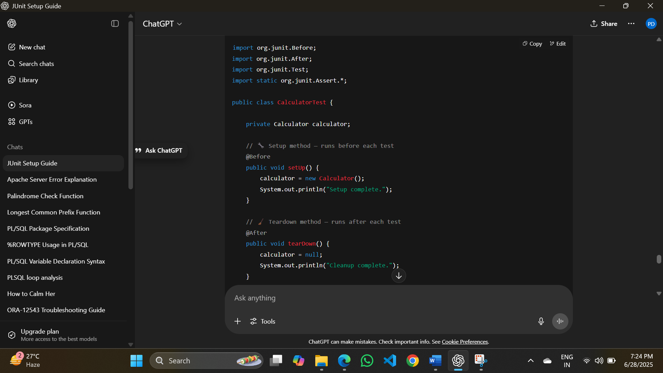

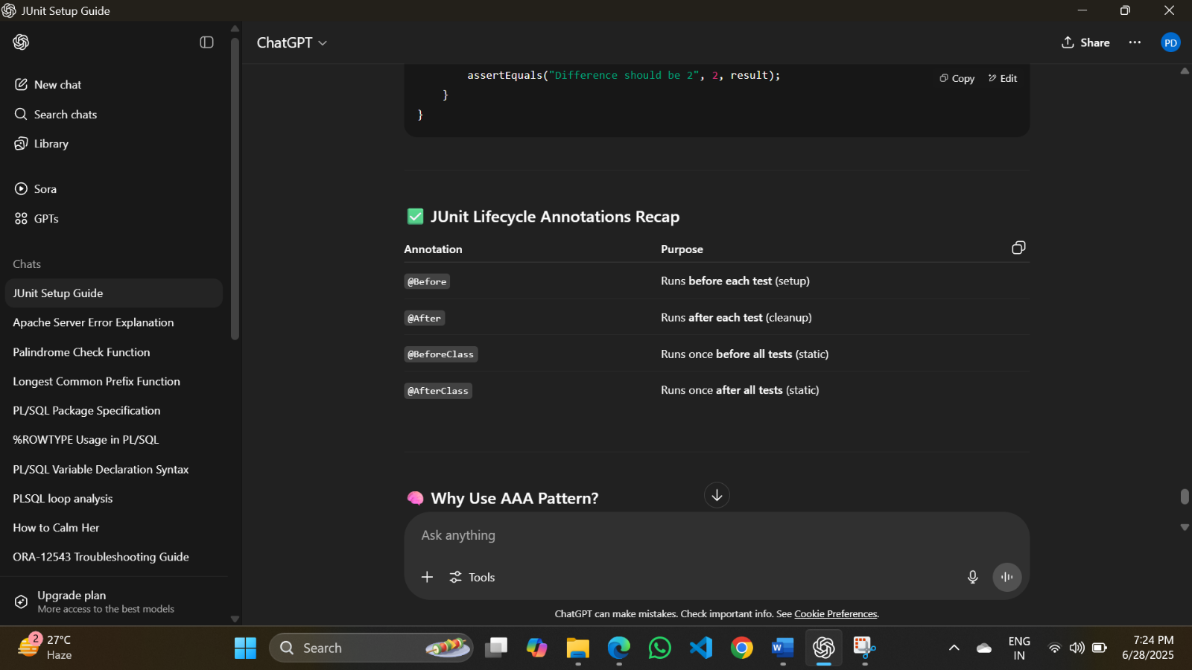

**OUTPUT:**

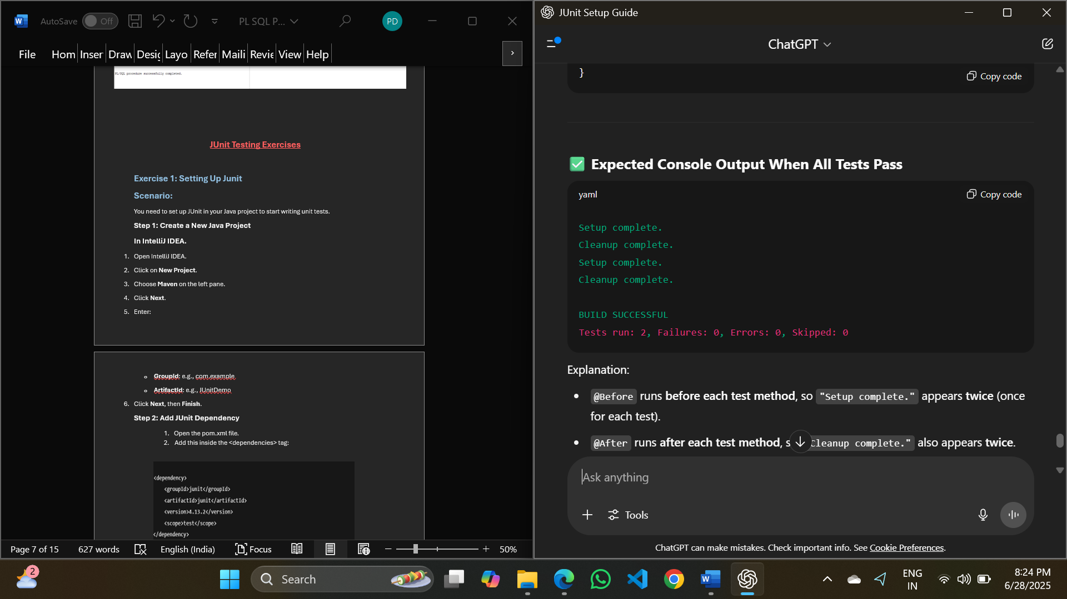

**Mockito Hands-On Exercises**

**Exercise 4: Mocking and Stubbing**

**Scenario:** You need to test a service that depends on an external API. Use Mockito to mock the external API and stub its methods.

**Solution Code:**

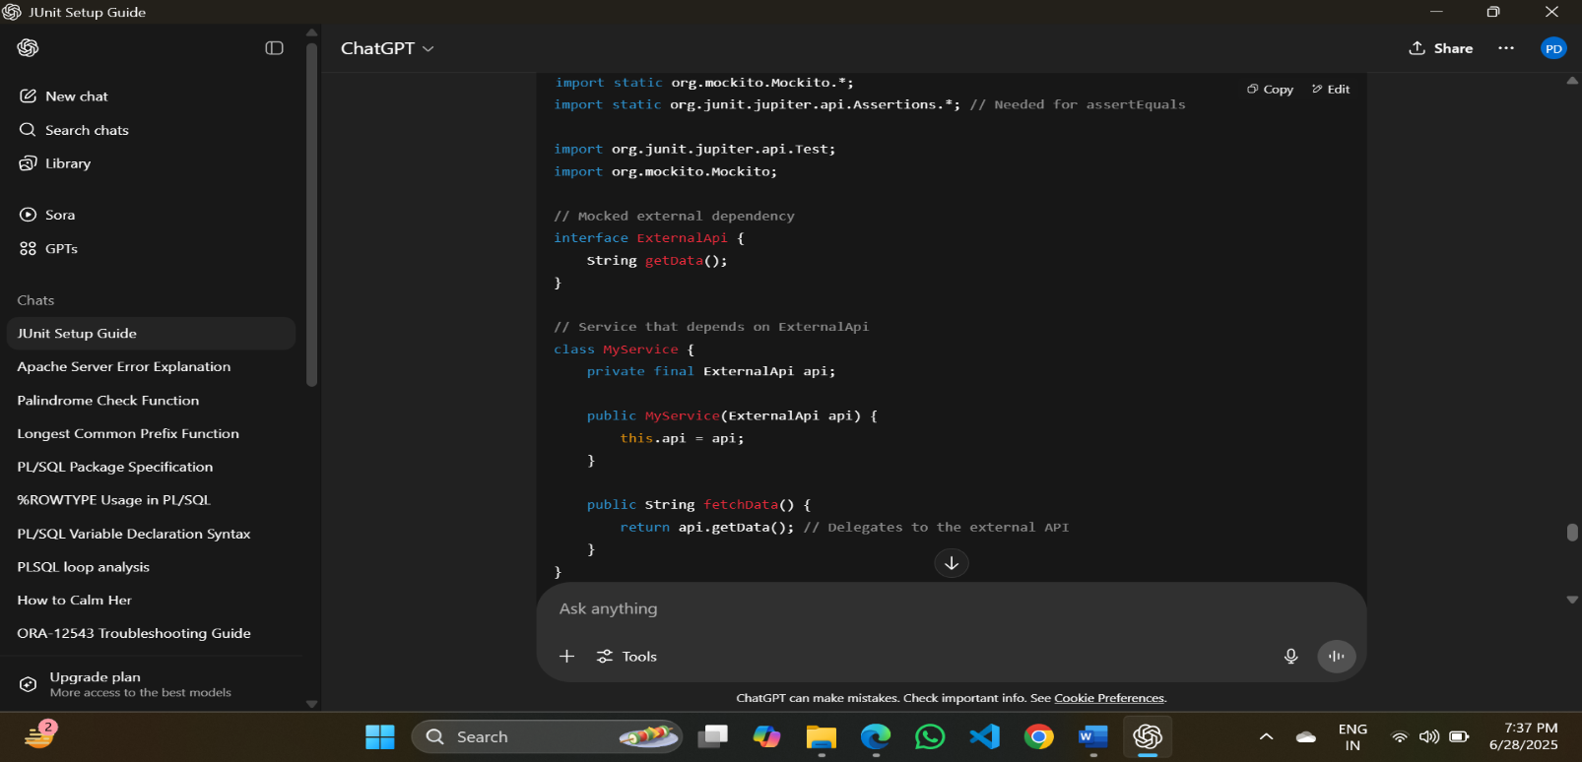

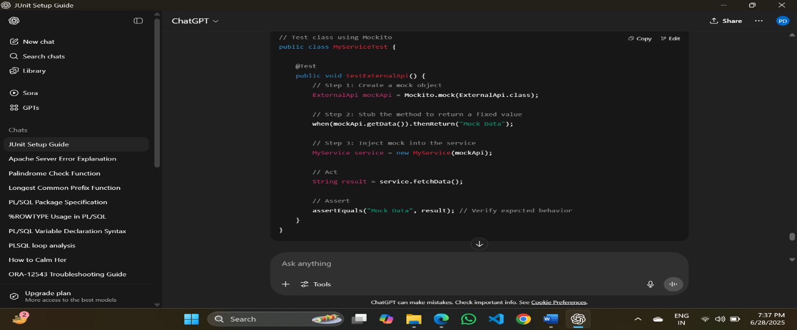

**Add Mockito and JUnit 5 to Maven:**

Add the following to your pom.xml:

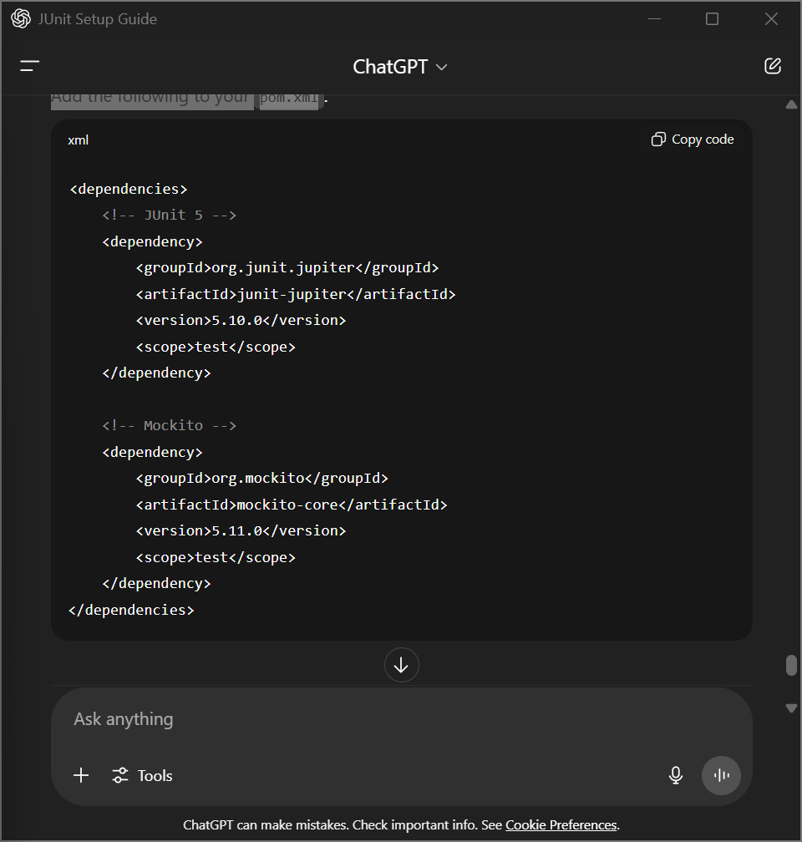

**OUTPUT:**

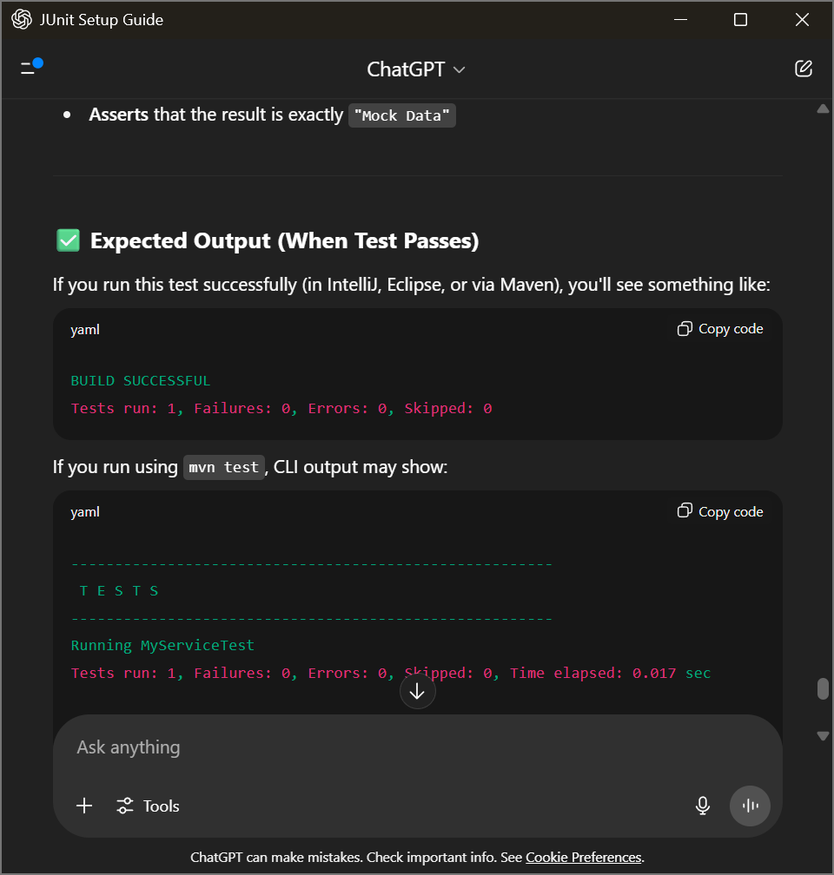

**Exercise 5: Verifying Interactions**

**Scenario:**

You need to ensure that a method is called with specific arguments.

Solution Code:

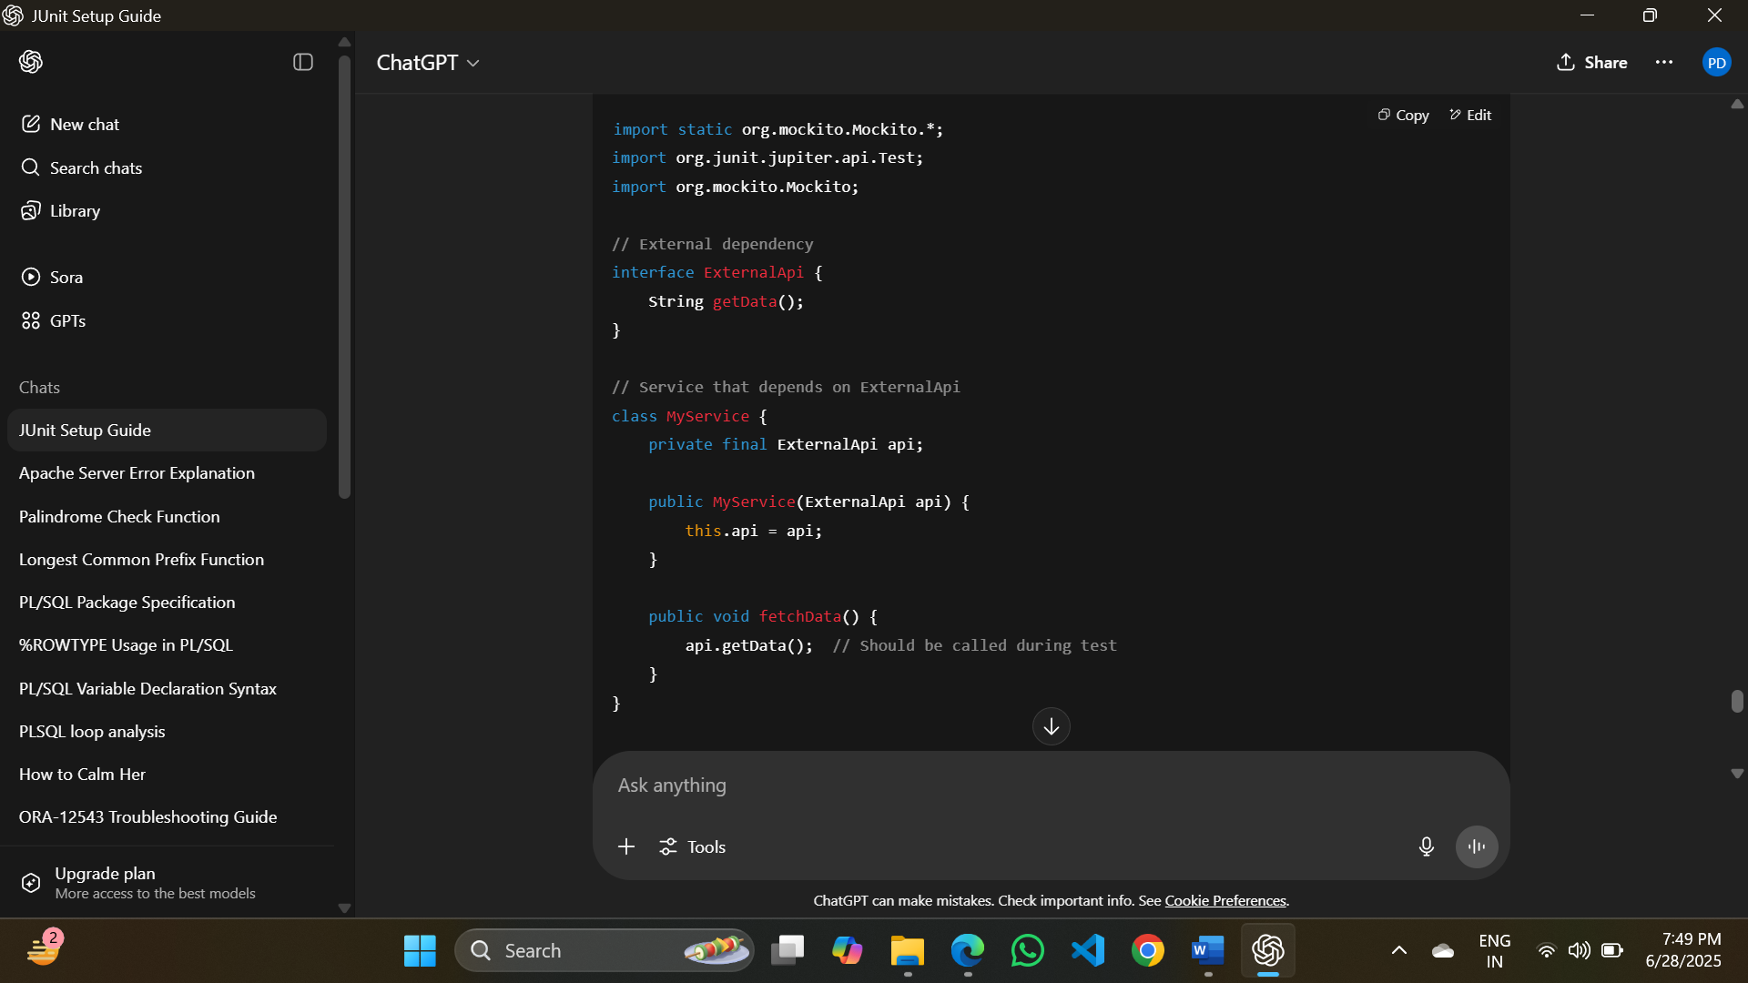

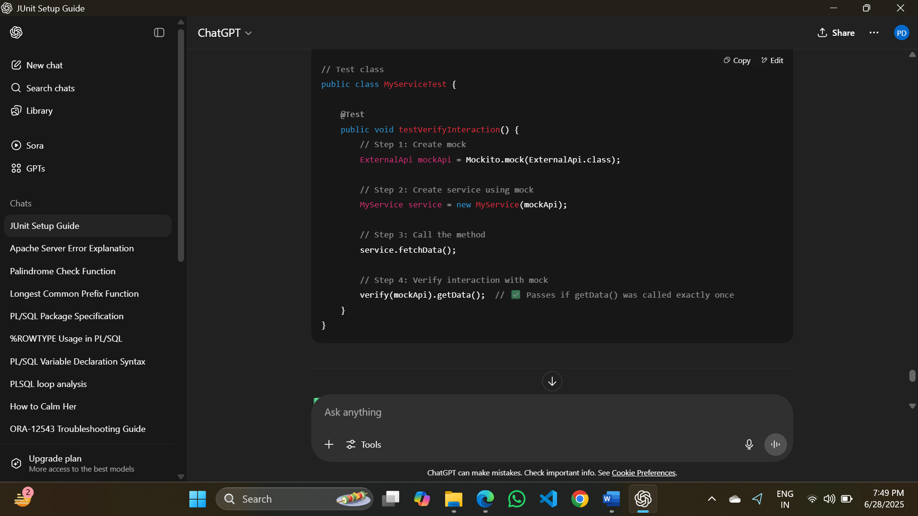

**You Can Also Verify with Arguments**

If a method accepts parameters, you can do:

verify(mockApi).getUserById(42); // Verifies method was called with argument 42

**OUTPUT:**

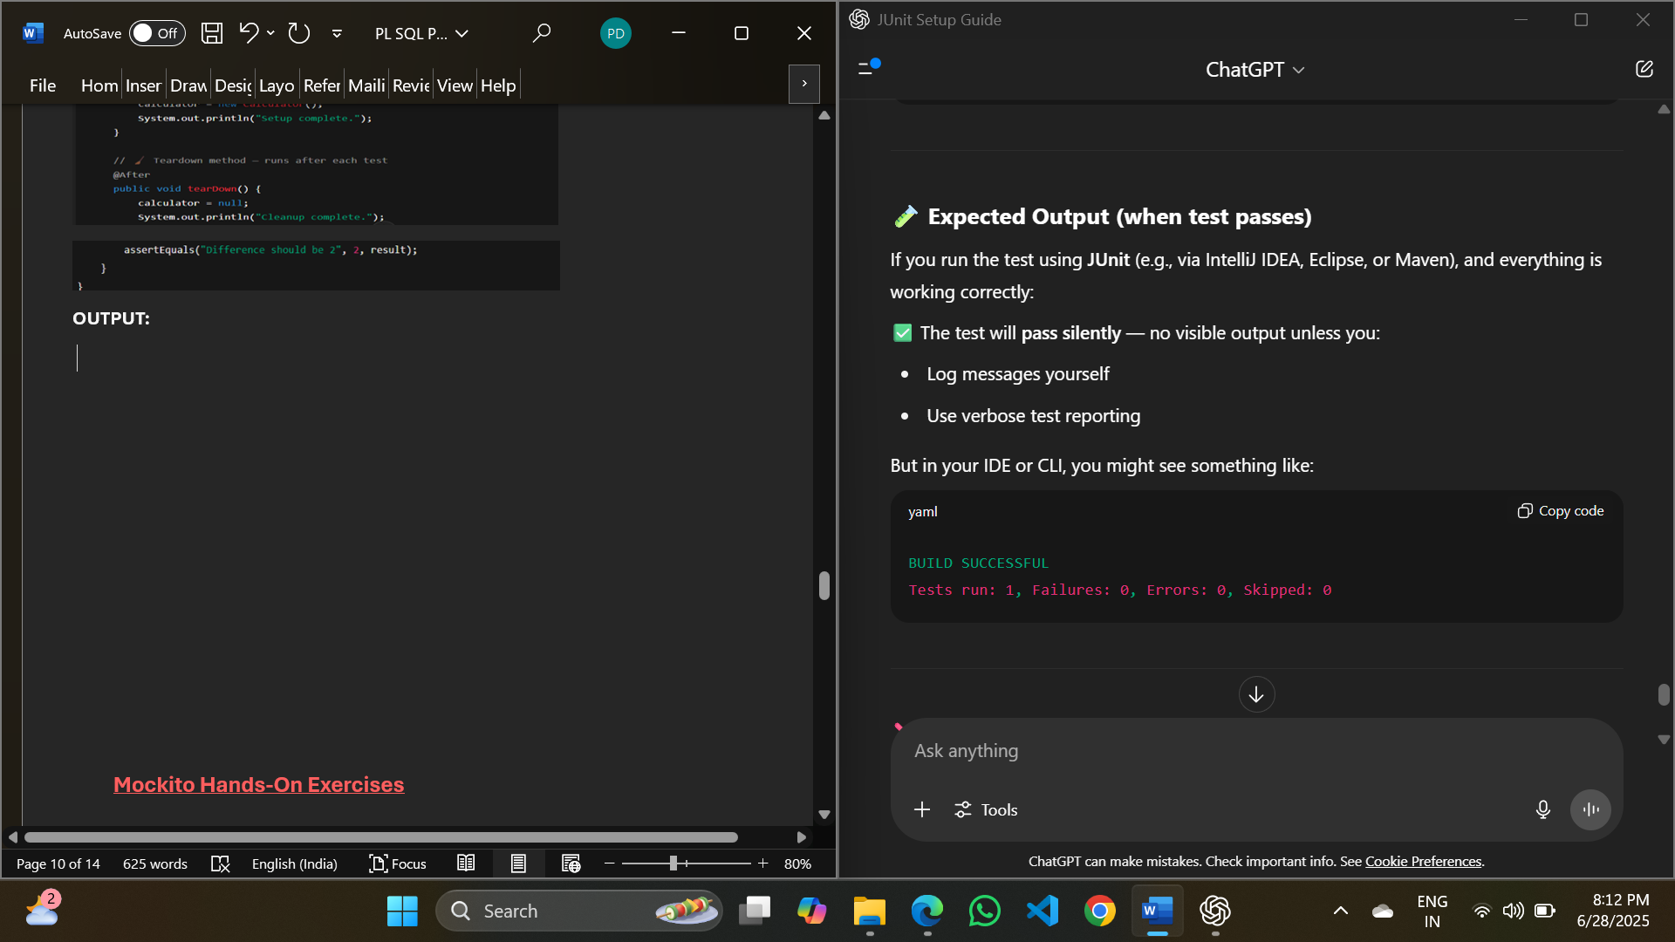

**Logging using SLF4J**

**Exercise 6: Verifying Interactions**

**Scenario:**

Task: Write a Java application that demonstrates logging error messages and warning levels using SLF4J.

**Step 1: Add Dependencies in pom.xml:**

Include these in the <dependencies> section of your Maven pom.xml:

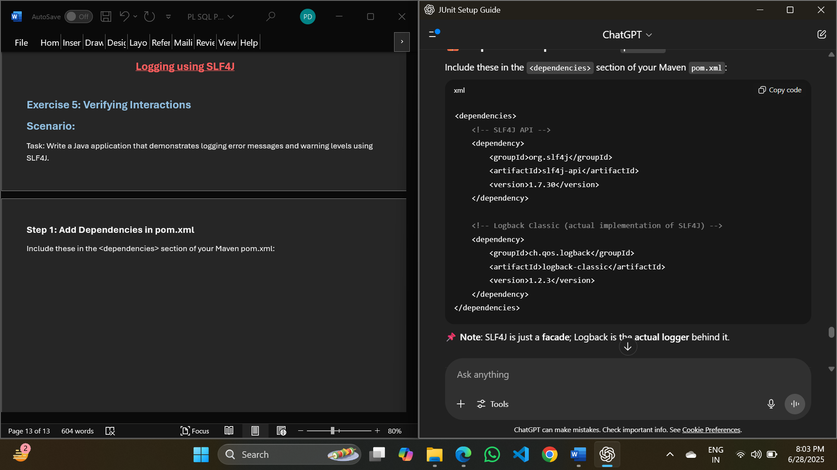

**Note**: SLF4J is just a **facade**; Logback is the **actual logger** behind it.

**Step 2: Java Class Using SLF4J:**

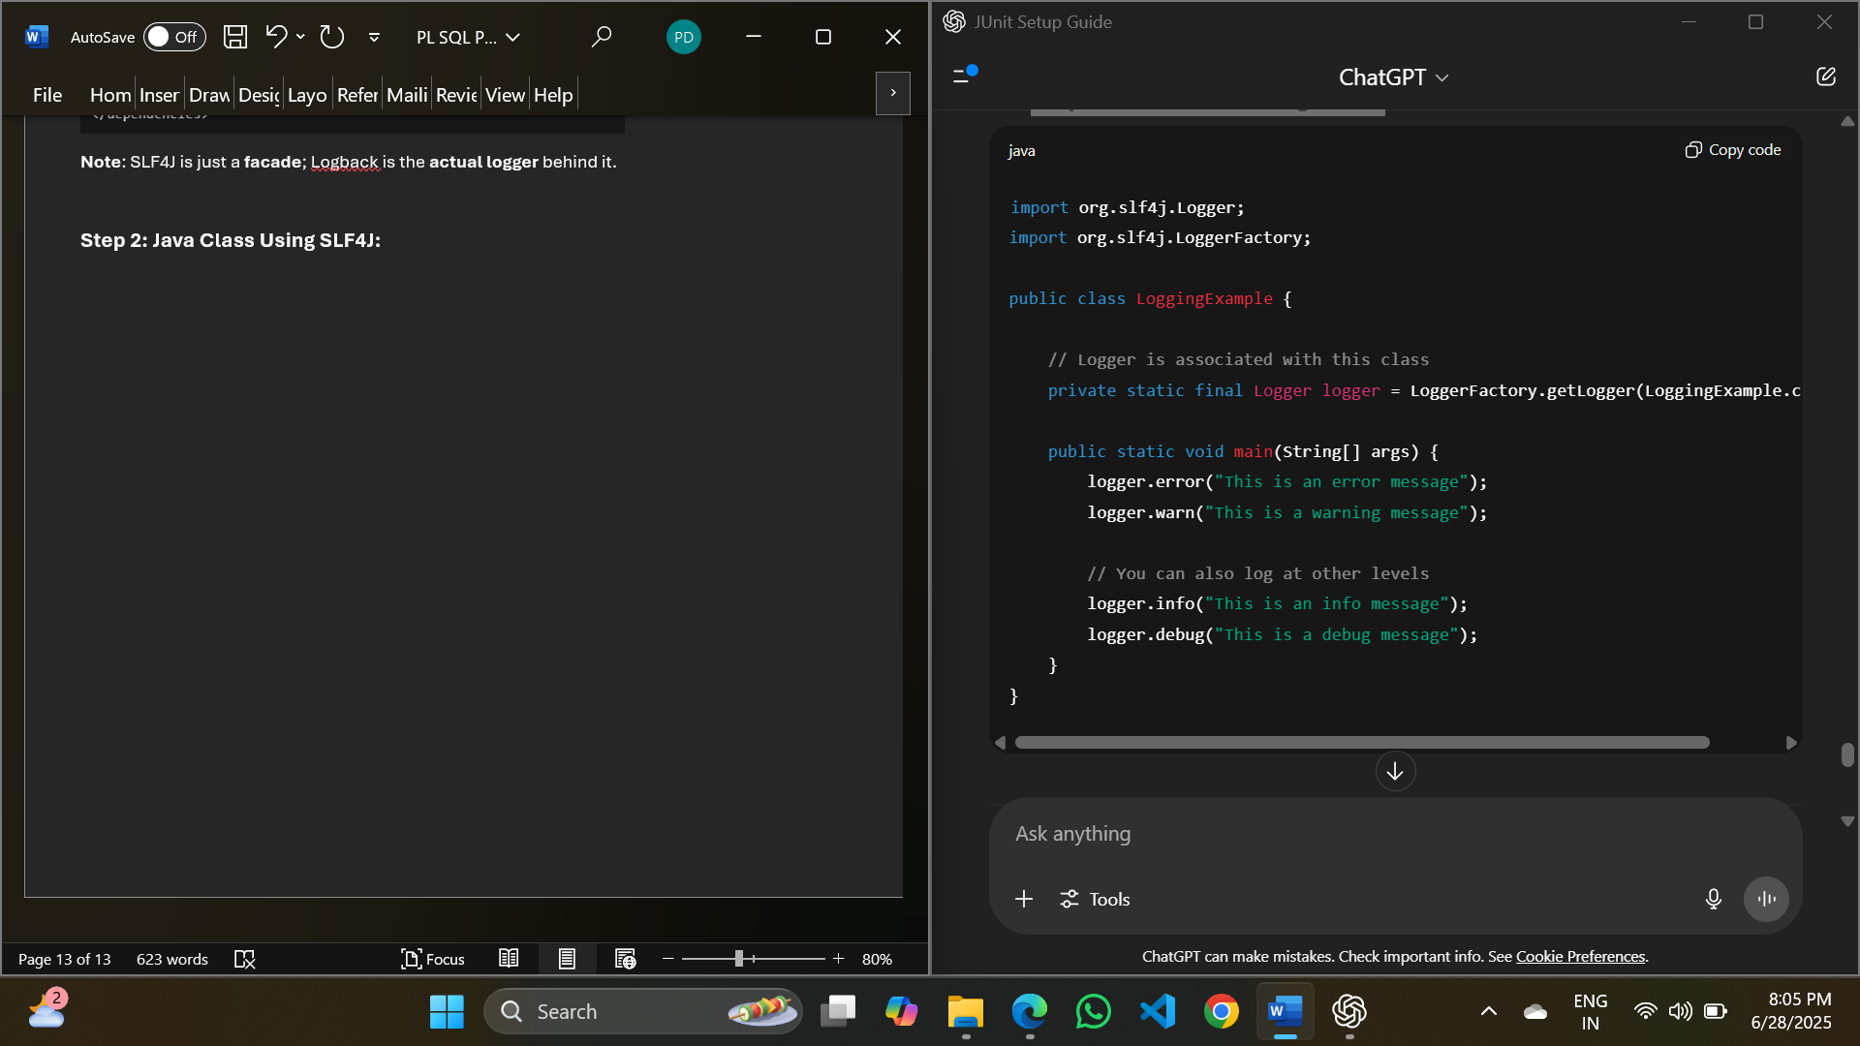

**OUTPUT:**

